My civilization is called _________________________________________

My civilization is located… (circle **one**)

* 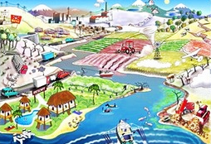next to an ocean
* in the mountains
* on an island
* in the rainforest
* next to a river
* in the desert

My civilization raises… (circle **two**)

* 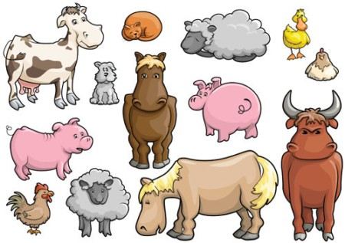horses
* chickens
* camels
* llamas
* cows
* cats
* dogs
* fish

My civilization grows… (circle **two**)

* corn
* 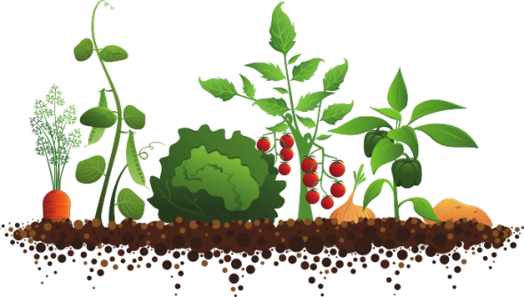wheat
* potatoes
* beans
* oranges
* pine trees
* roses

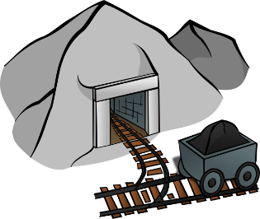My civilization also has… (pick **two**)

* gold
* iron
* stone
* silk
* bronze

Each turn, you will fill in one row on the scoresheet below based on the random events, trades and wars that take place during that turn.

|  |  |  |  |
| --- | --- | --- | --- |
|  | **Encounters with other civilizations**  **(trades and wars go here)** | **What happened within my civilization this year?**  **(random events go here)** | **Population at the end of the year** |
| **Year Zero** | None (phew!) | New civilization +100 | 100 citizens |
| **Year One** | None (phew!) |  |  |
| **Year Two** | I traded with ________________________  and received ________________________  in exchange for ______________________ |  |  |
| **Year Three** | I went to war and lost  ___________________ soldiers |  |  |
| **Year Four** | I traded with ________________________  and received ________________________  in exchange for ______________________ |  |  |
| **Year Five** | I went to war and lost  ___________________ soldiers |  | Final score: |